BANK LOAN REPORT QUERY DOCUMENT
BANK LOAN REPORT | SUMMARY
Total loan applications

select count(id) as 'total loan applications' from bank_loan_data

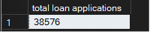
MTD loan applications

select count(id) as 'total loan applications'
from bank_loan_data
where month(issue_date) = 12 and year(issue_date) = 2021

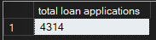

Previous MTD loan applications

select count(id) as 'PMTD loan applications'
from bank_loan_data
where month(issue_date) = 11 and year(issue_date) = 2021

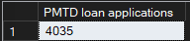

Total funded amount

select sum(loan_amount) as 'total funded amount'
from bank_loan_data



MTD total funded amount

select sum(loan_amount) as 'MTD total funded amount'
from bank_loan_data
where month(issue_date) = 12 and year(issue_date) = 2021

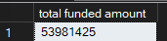

Total payment received

select sum(total_payment) as 'total payment received'
from bank_loan_data



MTD total payment received

select sum(total_payment) as 'mtd total payment received'
from bank_loan_data
where month(issue_date) = 12 and year(issue_date) = 2021

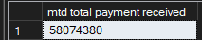

Average interest rate

select round(avg(int_rate) * 100,2) as 'Average interset rate'
from bank_loan_data

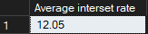

MTD Average interest rate

select round(avg(int_rate) * 100,2) as 'MTD Average interset rate'
from bank_loan_data
where month(issue_date) = 12 and year(issue_date) = 2021

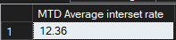

Avg DTI

select round(avg(dti) * 100,2) as 'Average DTI' from bank_loan_data

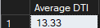

Avg MTD DTI

select round(avg(dti) * 100,2) as 'Average DTI' from bank_loan_data
where month(issue_date) = 12 and year(issue_date) = 2021

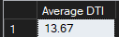

Good Loan Percentage

select
(COUNT(CASE WHEN loan_status = 'Fully Paid' OR loan_status = 'Current' then id END) * 100)
/
COUNT(id) as 'Good Loan Percentage'
FROM bank_loan_data

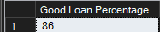

Good Loan Applications

select count(id) as 'Good Loan Applications' from bank_loan_data
where loan_status = 'Fully Paid' or loan_status = 'Current'

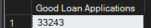

Good Loan Funded amount

select sum(loan_amount) as 'Good Loan funded amount' from bank_loan_data
where loan_status = 'Fully Paid' or loan_status = 'Current'

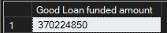

Good loan received amount

select sum(total_payment) as 'Good Loan received amount' from bank_loan_data
where loan_status = 'Fully Paid' or loan_status = 'Current'

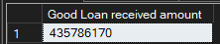

Bad Loan Percentage

select
(COUNT(CASE WHEN loan_status = 'Charged Off' then id END) * 100)
/
COUNT(id) as 'Bad Loan Percentage'
FROM bank_loan_data

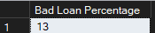

Bad Loan Applications

select count(id) as 'Bad Loan Applications' from bank_loan_data
where loan_status = 'Charged Off'

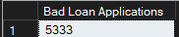

Bad Loan Funded amount

select sum(loan_amount) as 'Bad Loan funded amount' from bank_loan_data
where loan_status = 'Charged Off'

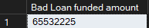

Bad loan received amount

select sum(total_payment) as 'Bad Loan received amount' from bank_loan_data
where loan_status = 'Charged Off'

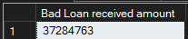

Loan Status

select
loan_status,
COUNT(id) as Total_Loan_Applications,
sum(total_payment) as total_amount_received,
sum(loan_amount) as total_funded_amount,
avg(int_rate * 100) as Interest_rate,
avg(dti * 100) as DTI
from
bank_loan_data
group by
loan_status

MTD Loan Status

select
loan_status,
sum(total_payment) as MTD_total_amount_received,
sum(loan_amount) as MTD_total_funded_amount
from
bank_loan_data
where
MONTH(issue_date) = 12
group by
loan_status

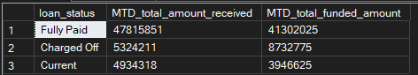

BANK LOAN REPORT | OVERVIEW

Month

SELECT
MONTH(issue_date) as Month_Num,
DATENAME(MONTH, issue_date) as Month_Name,
COUNT(id) as Total_Loan_Application,
SUM(loan_amount) as Total_Funded_Amount,
SUM(total_payment) as Total_Received_Amount
FROM bank_loan_data
group by MONTH(issue_date),DATENAME(MONTH, issue_date)
order by MONTH(issue_date)

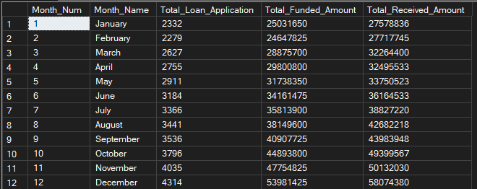

State

SELECT
address_state,
COUNT(id) as Total_Loan_Application,
SUM(loan_amount) as Total_Funded_Amount,
SUM(total_payment) as Total_Received_Amount
FROM bank_loan_data
group by address_state
order by SUM(loan_amount) DESC

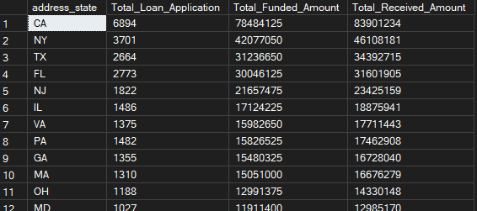

Term

SELECT
term,
COUNT(id) as Total_Loan_Application,
SUM(loan_amount) as Total_Funded_Amount,
SUM(total_payment) as Total_Received_Amount
FROM bank_loan_data
group by term
order by term

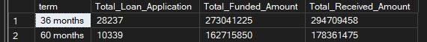

Emp Length
SELECT
emp_length,
COUNT(id) as Total_Loan_Application,
SUM(loan_amount) as Total_Funded_Amount,
SUM(total_payment) as Total_Received_Amount
FROM bank_loan_data
group by emp_length
order by COUNT(id) desc

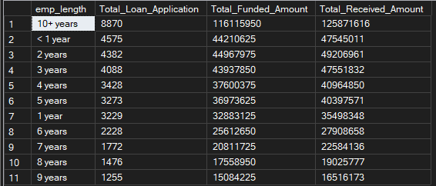

Purpose

SELECT
purpose,
COUNT(id) as Total_Loan_Application,
SUM(loan_amount) as Total_Funded_Amount,
SUM(total_payment) as Total_Received_Amount
FROM bank_loan_data
group by purpose
order by COUNT(id) desc

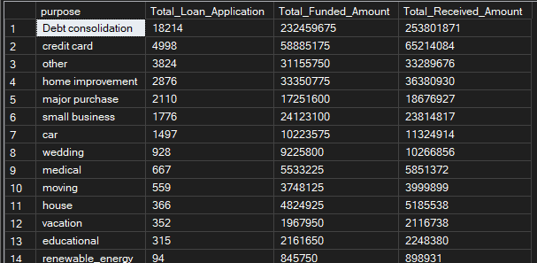

Home Ownership

SELECT
home_ownership,
COUNT(id) as Total_Loan_Application,
SUM(loan_amount) as Total_Funded_Amount,
SUM(total_payment) as Total_Received_Amount
FROM bank_loan_data
group by home_ownership
order by COUNT(id) desc

